Project Flow

|  |  |
| --- | --- |
| Date | 19 November 2022 |
| Team id | PNT2022TMID36289 |
| Project name | Fertilizers recommendation system for disease prediction |
| Maximum marks | 4 marks |

A digital camera or similar devices are used to take images of different types, and then those are used to identify the affected area in leaves. Then different types of imageprocessing techniques are applied to them, the process those images, to get different and useful features needed for the purpose of analyzing later-Plant leaf disease identification is especially needed to predict both the quality and quantity of the

First segmentation step primarily based on a mild polygonal leaf model is first achieved and later used to guide the evolution of an energetic contour.

Combining global shape descriptors given by the polygonal model with local curvature based features, the leaves are then classified overleaf datasets. In this research work introduce a method designed to deal with the obstacles raised by such complex images, for simple and plant leaves. A first segmentation step based on graph-cut approach is first performed and later used to guide the evolution of leaf boundaries, and implement classification algorithm to classify the diseases and recommend the fertilizers to affected leaves as shown in Figure 1.

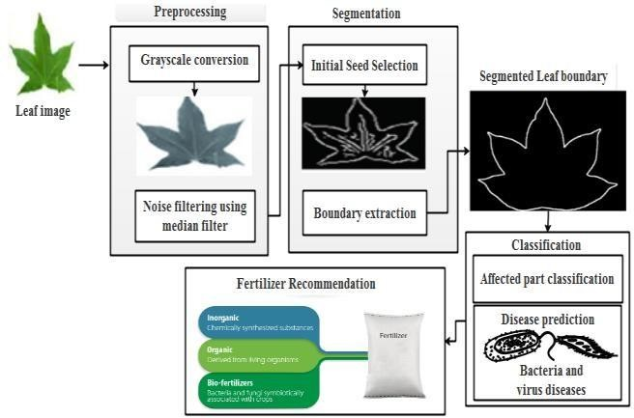

***Figure.1*** *Proposed Architecture*